Big Al by Andrew Clements, illustrated by Yoshi

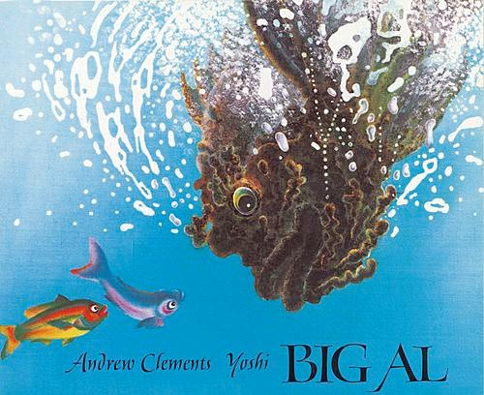
expect: I expect that the bus will pick me up every weekday morning.
trust: Ashley trusts Kayla to be on time because she always has been in the past.
clumsy: The clumsy clown kept tripping over his feet.
tremendous: they needed a bulldozer to move that tremendous rock.
congenial: The congenial group enjoyed one another’s company.
determined: My brother is determined to run a mile in less than eight minutes.

