Dear Juno by Soyung Pak and Illustrated by Susan Kathleen Hartung
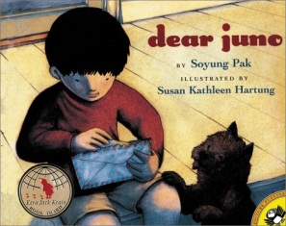

gentle: Be gentle when you hold a kitten.

soared: Ethan’s paper airplane soared above the tree branches.

noticed: I noticed that my feet felt more comfortable in the new shoes.

crisp: The crisp air outside felt good after being on the hot, crowed bus.

communicate: We communicate with our pen pals by writing letters back and forth.

eager: We were eager to find out which game we were going to play in gym class.

