Cuddly Dudley by Jez Alborough
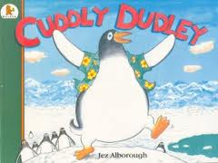
adorable: The baby was so adorable that everyone wanted to hug him.
enormous: An elephant is an enormous animal.
resist: I could not resist eating the cookies because they smelled so good.

lonely: The little girl sitting by herself on the swings seemed very lonely.
annoyed: I was annoyed when my brother talked to me while I was in the middle of playing a memory game.

gregarious: Tonya was very gregarious and was always inviting friends over to play.

